Stay informed: Keep up to date with the latest trends and emerging technologies by reading industry publications, attending conferences and events, and following thought leaders in the field.

Technology is advancing at an unprecedented pace. In just the last few years, we've seen the rise of technologies like artificial intelligence, virtual reality, and the Internet of Things.

Conduct research: Conduct research on emerging technologies, user behaviors, and market trends. Use this research to inform your design decisions and anticipate future needs and demands.

Think outside the box: Challenge assumptions and think creatively about how emerging technologies can be used to solve problems and improve user experiences.

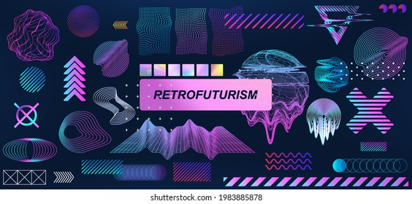

AN ART FORM POPULAR AMONG ysu of gaminf (a billion dollar industry)

Prototype and test: Create prototypes and test them with users to see how they respond to emerging technologies and design concepts. Use feedback to refine your designs and anticipate future needs.

Collaborate with experts: Work with experts in emerging technologies and related fields to stay ahead of the curve and anticipate future trends.

Iterate and adapt: Designing for the future requires constant iteration and adaptation. Stay flexible and be willing to change course as new trends and technologies emerge.

understanding of user needs and behaviors.

ake risks, experiment, and iterate quickly.